You should put the four libraries into the libraries directory of Arduino IDE.

And the example codes are in directory of

D:\arduino-1.6.5-r2\libraries\VirtualWire\examples\RFtransmitter

把箭头指向的程序库放到Arduino IDE的libraries目录下，应用例程所在的目录是

D:\arduino-1.6.5-r2\libraries\VirtualWire\examples\RFtransmitter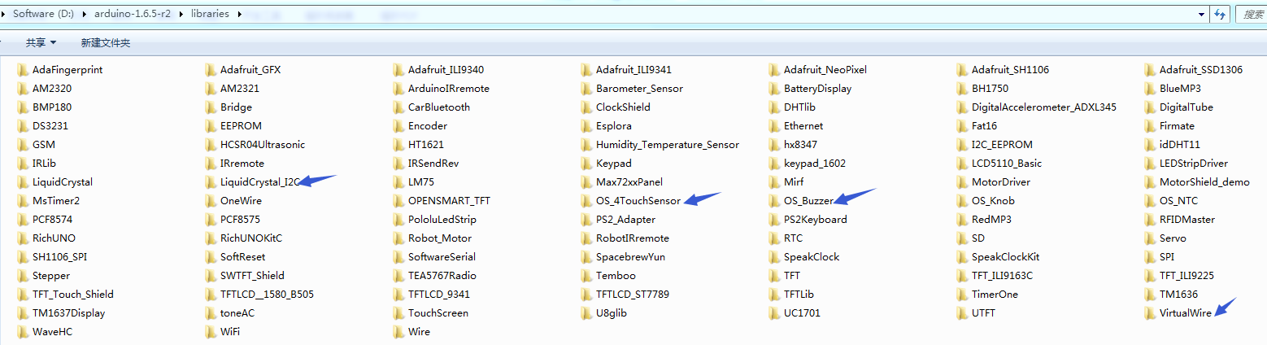

**Pins wiring guide**

|  |  |  |
| --- | --- | --- |
|  |  | IO Expansion Shield  (Plug onto OPEN-SMART UNO R3) |
| Transmitter Module (onboard square module) | SIG | D2 |
| VCC | VCC |
| GND | GND |
| 4-Channel Touch Sensor | O1 | D3 |
| O2 | D4 |
| O3 | D5 |
| O4 | D6 |
| VCC | VCC |
| GND | GND |
| Buzzer Module | SIG | D8 |
| VCC | VCC |
| GND | GND |